Zebrock : The body in all its « states »

Zebrock is an association whose aim is to convey the values of music to young people. Indeed this association allows to discover musical diversity, in particular the conference is a project of musical culture aiming at the appropriation of the songs and music genres of our everyday life. Here the theme of the conference is "the body in all these states". Two artists were present, Mystic and Singe. They showed us how music could convey emotions, make us sad or happy. So we could feel very strong the desire to move with the different rhythms, the desire to express our feelings (positive or negative) or the desire to know more about the origins of music.
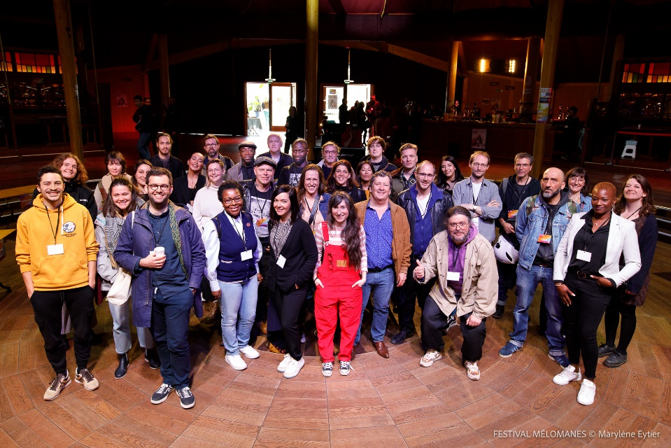
Your choices of music are interesting and well chosen, all of them show a differrent criticism of society, for example, «Four women » by Nina Simone in 1966 denounces the oppression suffered by women in the United States, or « Les nageuses » by Gisèle Pape in 2021 which has particulary affected us by its strong rhythm evoking the athletes of the women’s swimming team of Germany in the 70’s. This song is a good example of the power of music that can in this case go as far as to give us the goosebumps.
Here is our interview of Singe and Mystic Gordon, the two performers :
-What kind of music did you prefer to perform and why ?
I personally prefer the songs rooted in Black American music : they’re really interesting to play with the instruments, and vocally they offer an amazing playground to express yourself, because these cultures were created by people oppressed by society but not giving up and screaming their worth and their humanity in their music.

- What was the message that you wanted to convey and why did you choose to perform to high school students ?
We want to stress how beautiful music is and the power it has. Some people think it’s not for them, and they’re wrong : anybody can express itself through music and find confort in it. Also, we realize a lot of high school students have never seen a show in their life and we want to encourage them to go out to see concerts. A lot of concert rooms are funded by public money but are unknown from the public !

We enjoyed this performance, first, because the songs were interesting and well chosen, each of them expressed themselvesin a different way. Secondly, the fact that they took the time between each music to explain to us the fight of each song. They also explained to us by which means these songs conveyed their message thanks to their rhythm. So this taught us precisely the role of music. And finally, Singe and Mystic were cool and energetic, they set a good mood and we had a good time.
Thanks for everything Zebrock and see you soon.

By Noah, Arthur, Lisa,Lily.

